**COMPUTER ORGANIZATION AND ASSEMBLY LANGUAGE**

**PROJECT REPORT**

**PROJECT NAME: PHARMACY BILLING MANAGEMENT SYSTEM**

**Submitted to:**

Ms. Amna Sarwar

**Group Members:**

Um e Aimen (uw-22-cs-bs-023)

Eman AbaidUllah (uw-22-cs-bs-024)

Rimsha Shaheen (uw-22-cs-bs-034)

**Semester/Section:**

BSCS-3rd A

**Department of Computer Science,**

**University of Wah**

1. **Introduction:**

Pharmacy billing management system is a platform from where the customer can order and purchase medicines online. This system plays a crucial role as the customer can order medicines while staying at home and their order will be at their home on time.

# **Features:**

# **Customer Information(name)**

# **Password for login**

# **Order Medicine**

# **Enter name of Medicine**

# **Enter quantity of Medicine**

1. **Code:**

ExitProcess proto

WriteString proto

ReadInt64 proto

ReadString proto

WriteInt64 proto

Crlf proto

.data

UserNamePrompt db "Enter User Name: ",0

PasswordPrompt db "Enter password for Login: ", 0

InvalidPasswordPrompt db "Invalid password. Exiting.", 0

SuccessPrompt db "Login successful.", 0

WelcomeMessage db "*****// Welcome to Pharmacy Billing Management System //*****", 0

OrderOption db "1. Press 1 to order medicines.", 0

CancelOption db "2. Press 2 to cancel.", 0

InvalidChoice db "Please Enter Correct Choice ",0

OrderPrompt db "What medicines would you like to order?", 0

MedicineOptions db "1) Panadol", 0

MedicineOptions1 db "2) Paracetamol", 0

MedicineOptions2 db "3) Aspirin", 0

MedicineOptions3 db "4) Ibuprofen", 0

MedicineOptions4 db "5) Cough Syrup", 0

MedicineOptions5 db "6) ActifiedPCold", 0

MedicineOptions6 db "7) Calpol", 0

MedicineOptions7 db "8) Ciprofloxacin", 0

MedicineOptions8 db "9) Medrol", 0

MedicineOptions9 db "10) Indocin", 0

QuantityPrompt db "Enter quantity:", 0

OrderVerification db "--------Your Order is Verified---------", 0

TotalBill db "Your Total Bill is: $", 0

DeliveryTime db "Your Order Will be delivered in 30 Minutes", 0

ThanksMessage db "Thank you For Ordering From Pharmacy", 0

RecalculatePrompt db "Press 1 to To order again.", 0

ExitPrompt db "Press 2 to EXIT.", 0

pass dq ?

name dq ?

num dq ?

quan dq ?

res dq ?

.code

main proc

call crlf

call crlf

mov rdx, offset UserNamePrompt

call WriteString

mov rcx, 10

call readstring

; Ask for password

mov rdx, offset PasswordPrompt

call WriteString

mov rax, 0

call ReadInt64

mov pass, rax

cmp rax, 100123

je Successful

jmp invalid_login

Successful:

call crlf

mov rdx, offset SuccessPrompt

call WriteString

call crlf

main1:

call crlf

mov rdx, offset WelcomeMessage

call WriteString

call crlf

mov rdx, offset OrderOption

call WriteString

call crlf

mov rdx, offset CancelOption

call WriteString

call crlf

mov rax, 0

call ReadInt64

mov num, rax

cmp rax, 1

je main2

cmp rax, 2

je exit_program

cmp rax, num

je Invalid

Invalid:

mov rdx, offset InvalidChoice

call WriteString

call crlf

jmp main1

main2:

mov rdx, offset OrderPrompt

call WriteString

call crlf

mov rdx, offset MedicineOptions

call WriteString

call crlf

mov rdx, offset MedicineOptions1

call WriteString

call crlf

mov rdx, offset MedicineOptions2

call WriteString

call crlf

mov rdx, offset MedicineOptions3

call WriteString

call crlf

mov rdx, offset MedicineOptions4

call WriteString

call crlf

mov rdx, offset MedicineOptions5

call WriteString

call crlf

mov rdx, offset MedicineOptions6

call WriteString

call crlf

mov rdx, offset MedicineOptions7

call WriteString

call crlf

mov rdx, offset MedicineOptions8

call WriteString

call crlf

mov rdx, offset MedicineOptions9

call WriteString

call crlf

mov rax, 0

call ReadInt64

cmp rax, 1

je Panadol

cmp rax, 2

je Paracetamol

cmp rax, 3

je Aspirin

cmp rax, 4

je Ibuprofen

cmp rax, 5

je CoughSyrup

cmp rax, 6

je ActifiedPCold

cmp rax, 7

je Calpol

cmp rax, 8

je Ciprofloxacin

cmp rax, 9

je Medrol

cmp rax, 10

je Indocin

Panadol:

mov rax, 45

jmp QuantitySelection

Paracetamol:

mov rax, 50

jmp QuantitySelection

Aspirin:

mov rax, 80

jmp QuantitySelection

Ibuprofen:

mov rax, 100

jmp QuantitySelection

CoughSyrup:

mov rax, 150

jmp QuantitySelection

ActifiedPCold:

mov rax, 90

jmp QuantitySelection

Calpol:

mov rax, 100

jmp QuantitySelection

Ciprofloxacin:

mov rax, 120

jmp QuantitySelection

Medrol:

mov rax, 190

jmp QuantitySelection

Indocin:

mov rax, 200

jmp QuantitySelection

QuantitySelection:

mov quan, rax

mov rdx, offset QuantityPrompt

call WriteString

call crlf

call ReadInt64

mov rbx, rax

mov rax, quan

imul rax, rbx ; Multiply quantity with medicine cost

mov res, rax

jmp CalculateBill

CalculateBill:

call crlf

mov rdx, offset OrderVerification

call WriteString

call crlf

mov rdx, offset TotalBill

call WriteString

mov rax, res

call WriteInt64

call crlf

mov rdx, offset DeliveryTime

call WriteString

call crlf

jmp optionsloop

optionsloop:

call crlf

mov rdx, offset RecalculatePrompt

call WriteString

call crlf

mov rdx, offset ExitPrompt

call WriteString

; Read user's choice

MOV RAX, 0

call ReadInt64

mov num, rax

; Process user's choice

cmp rax, 1

je recalculate

cmp rax, 2

je exit_program

cmp rax,num

je invalid1

invalid1:

mov rdx, offset InvalidChoice

call WriteString

call crlf

jmp optionsloop

recalculate:

jmp main2

invalid_login:

mov rdx, offset InvalidPasswordPrompt

call WriteString

call crlf

jmp Quit

exit_program:

mov rdx, offset ThanksMessage

call WriteString

call crlf

Quit:

call ExitProcess

main endp

end

1. **OUTPUT:**

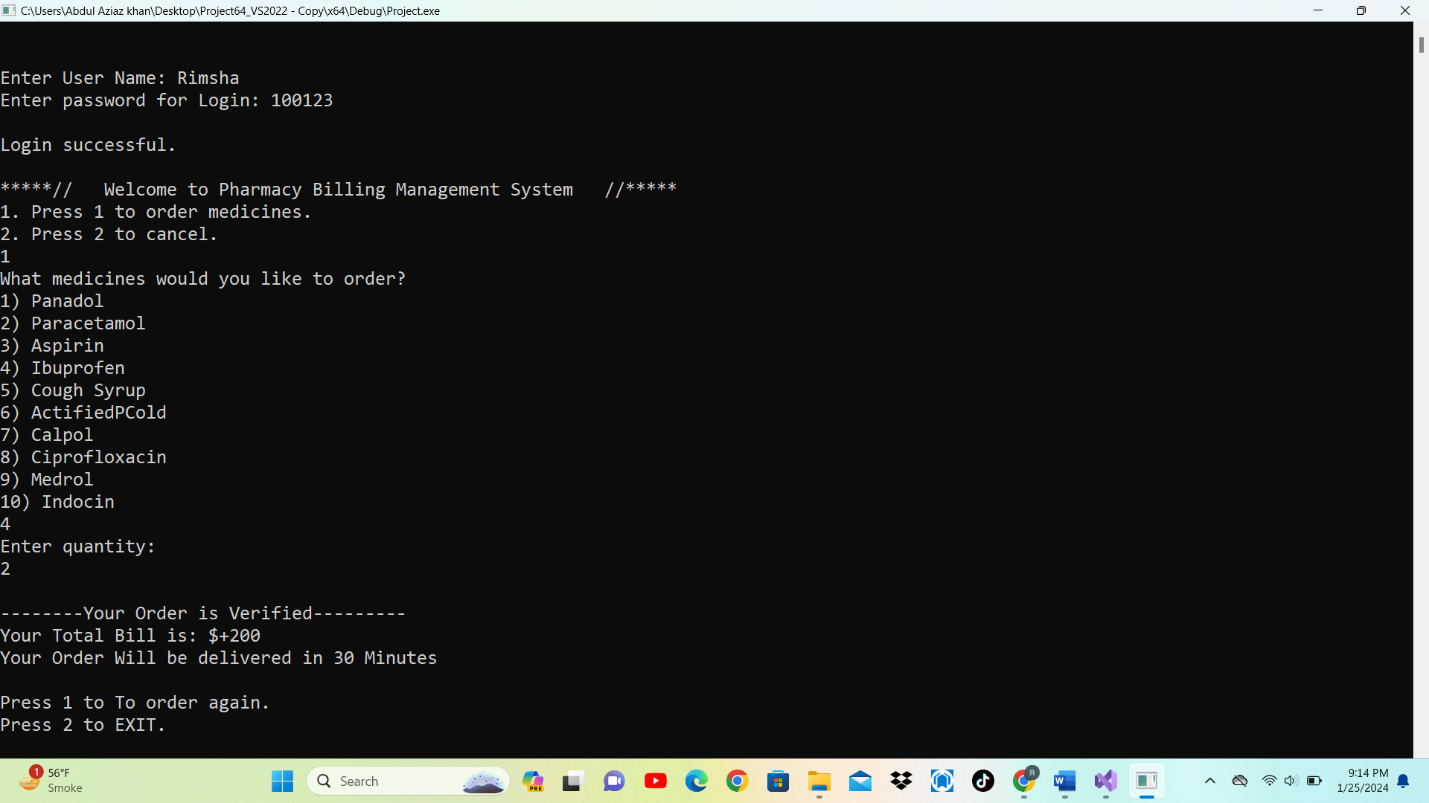

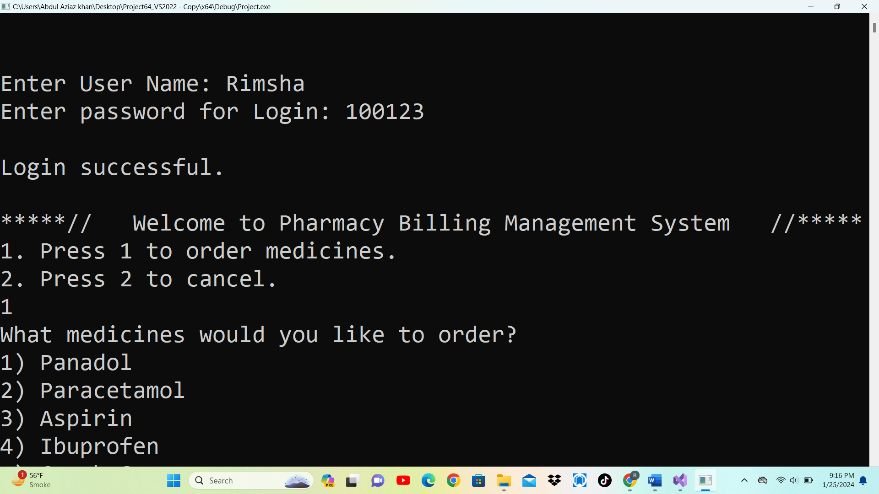

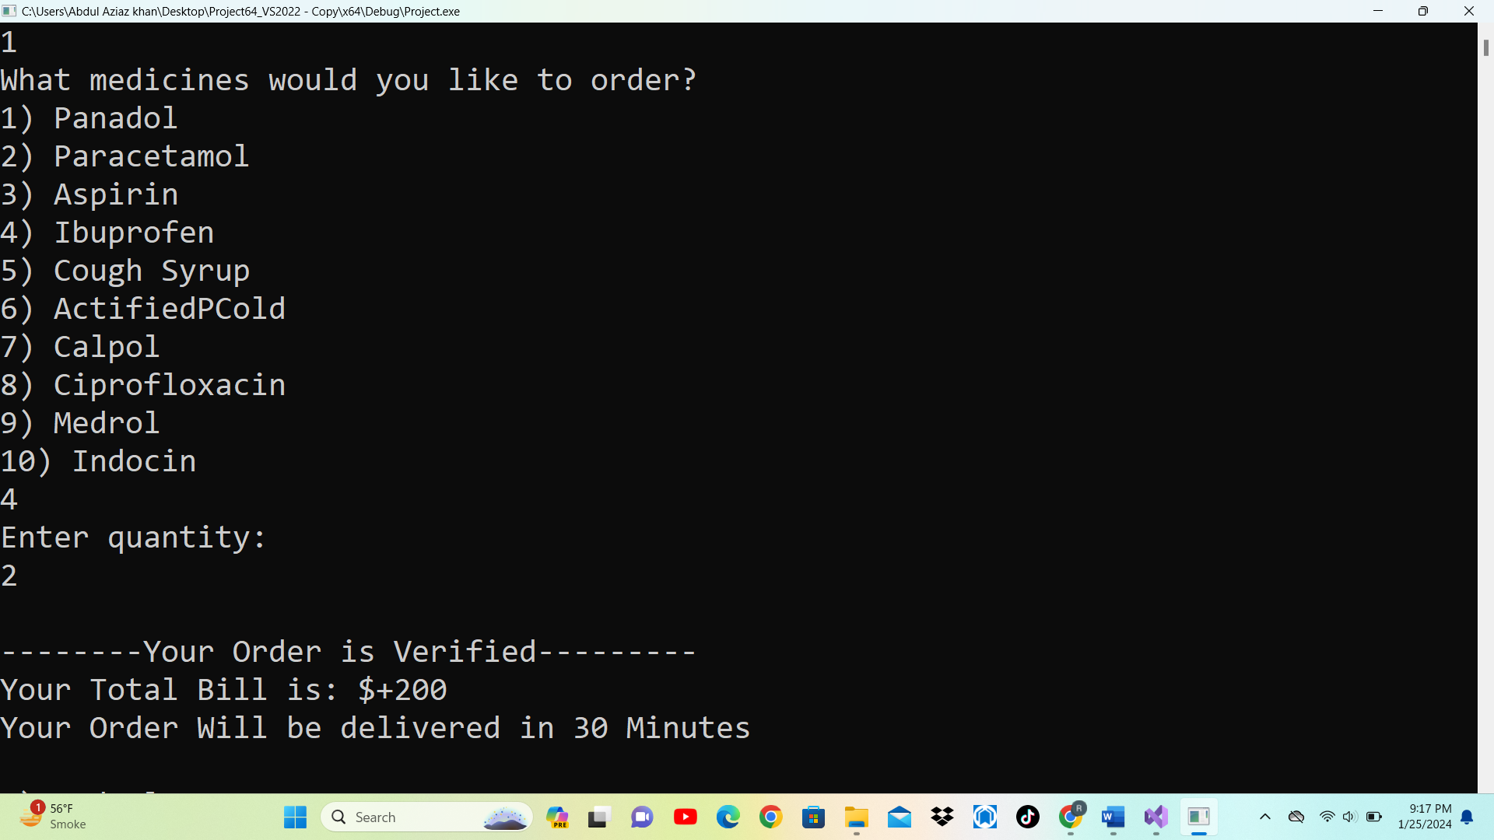

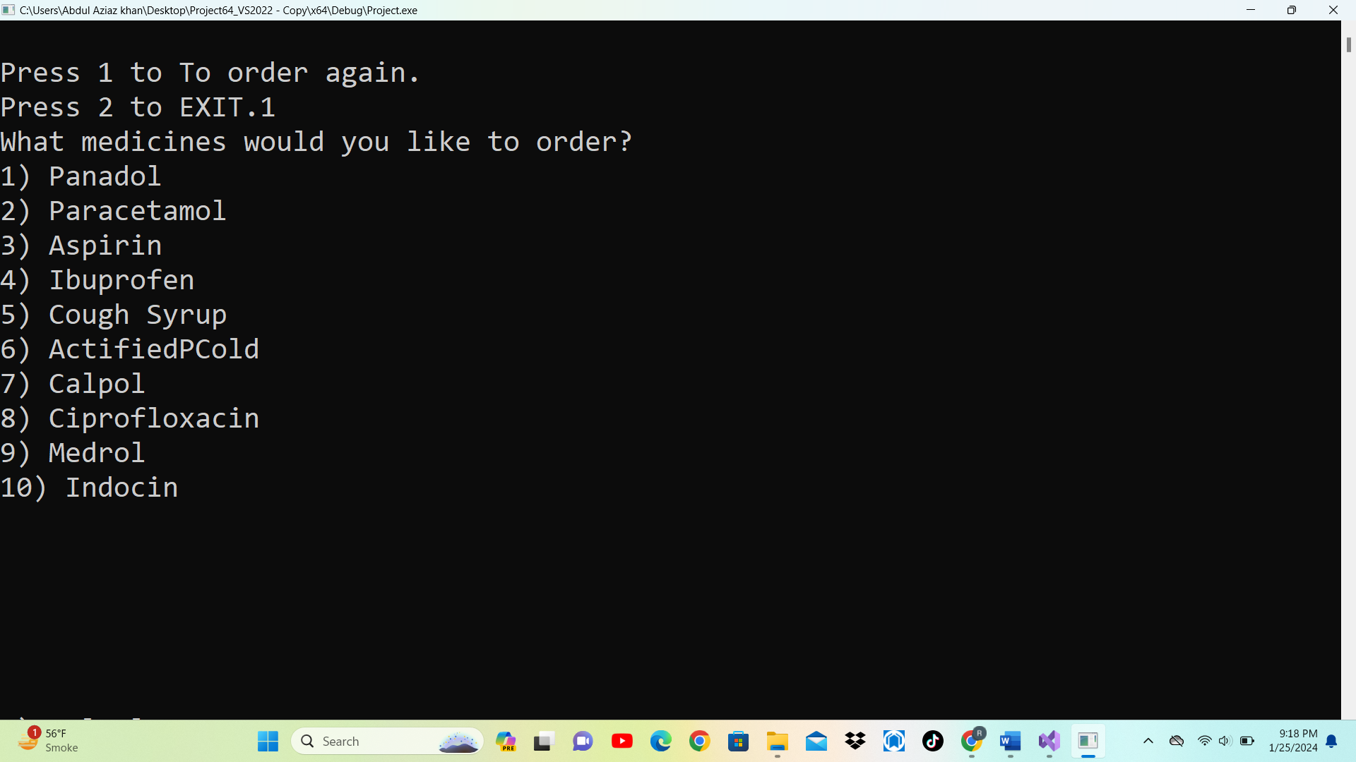

1. **GitHub Link:**

https://github.com/emanabaid/pharmacy-management-system.git

1. **Conclusion:**

The major conclusion of Pharmacy billing management systems is that it helps handle the task efficiently in the store. As we all know, pharmacy is one of the most considerable medical facilities that help to serve the major population of Healthcare.